
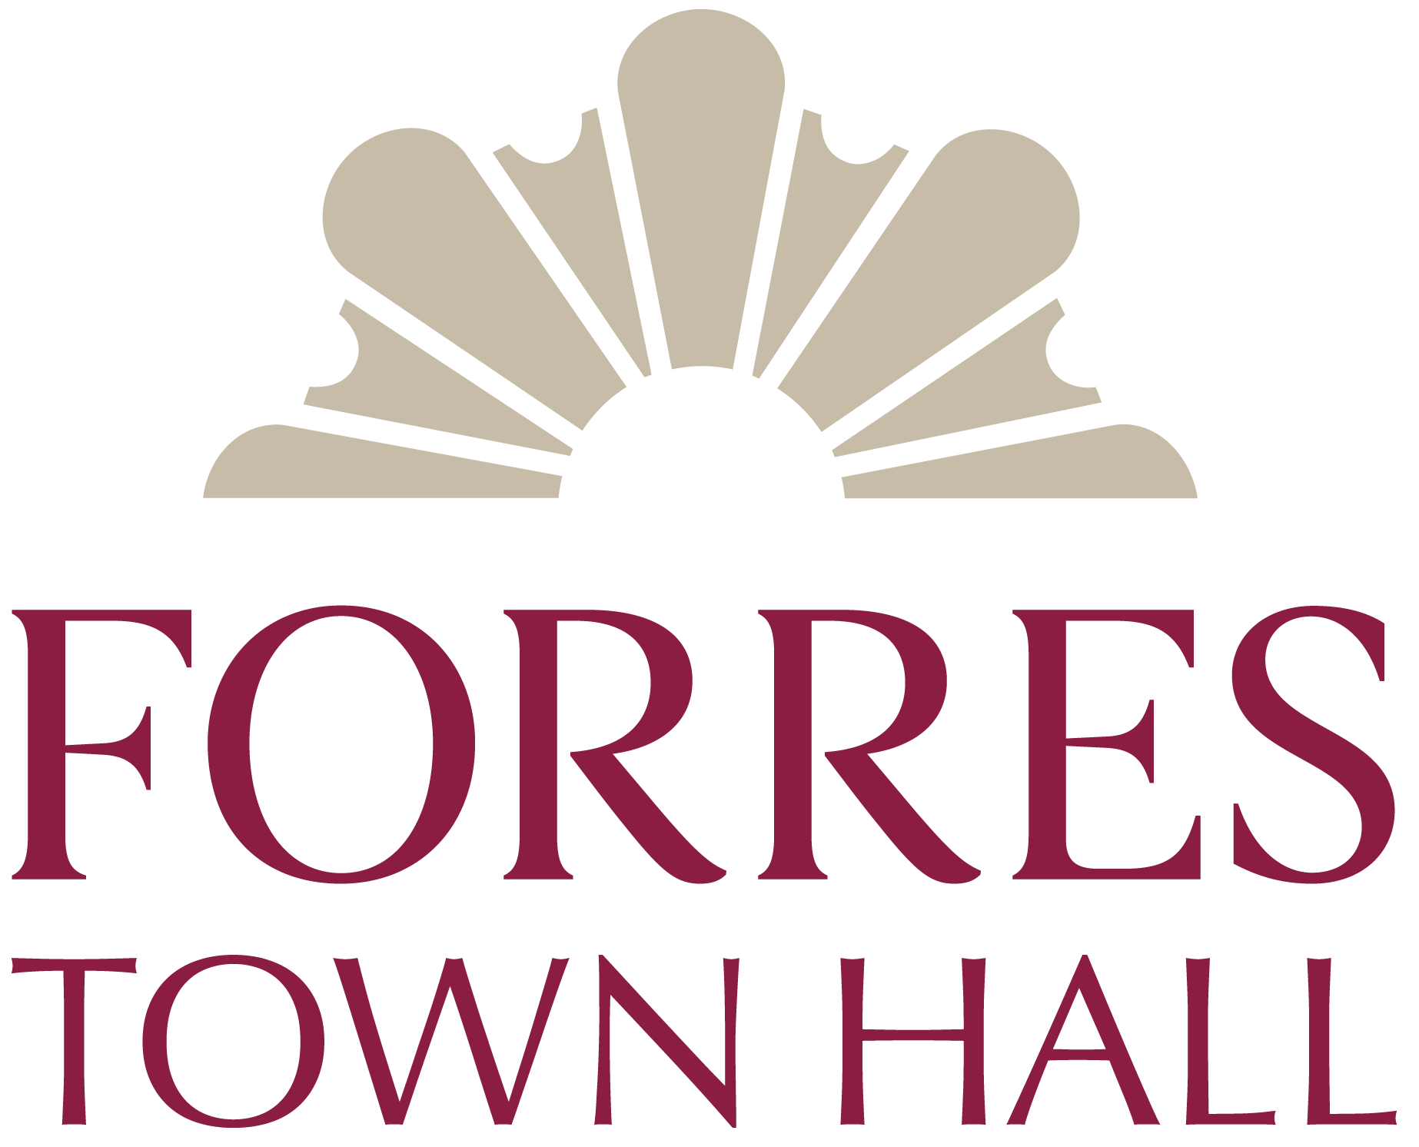


Application Form
Forres Town Hall Project Officer

Please complete all sections, sign and return this form, with a covering letter and any additional information, to Forres Area Community Trust, using the contact details provided at the end of this form

PERSONAL DETAILS

Full Name:
Address:
Email Address:
Telephone Number:

APPLICANT DETAILS
1. Education and Training; include any qualifications obtained and grades where relevant

2. Employment History; starting with current/most recent, include employer, job role and dates

3. Outline of Competencies - Skills, Abilities, Knowledge

Please indicate with specific examples how you meet each of the essential criteria listed on the person specification, with information on any of the desirable criteria which you also satisfy. If you currently satisfy only some of the essential criteria, please outline how you plan to obtain the required level of competency.

4. What are your reasons for applying for the post?

Please nominate two referees, one of which should be your present or most recent employer, who can comment on your competencies. We will only approach referees after interviews.

Name |  | Name
Address |  | Address
Tel. |  | Tel.
Email |  | Email
Job Title |  | Job Title

Please tell us if you have any particular needs we should take into account when arranging interviews. The interview process will include questions from an interview panel.

Applicant’s signature: ____________________________________ Date: _____________

Please ensure that you have completed all the sections of the form and return with a covering letter to:
Please mark the envelope: Confidential

Forres Area Community Trust
Forres Town Hall
High Street
Forres
IV36 1PB

Or email to: info@forresarea.org
To arrive no later than Monday 23rd March at 12 noon

Phone: 01309 674388 Monday to Friday 10am to 1pm
Web: www.forresarea.org

