Information Pack to become a Director of  
Forres Area Community Trust

# Our Mission

To work together to make the Forres Area a better place to live, work and visit.

# This document sets out information relating to becoming a Director of FACT.

We recommend you read it, and the information it refers to, and then have a discussion with the Chair of FACT’s Board or another FACT Director before submitting your application. Further information about the formal process is set out in section 4.

## 1. Information about the Forres Area Community Trust (FACT)

FACT is the community development trust for the Forres Area. It is both a charity and a company limited by guarantee. The definition of the community it serves is the Forres Academy catchment area. This stretches from Alves in the east to Dyke in the west, north to Findhorn and south to Dallas.

FACT runs a number of funded projects that support the wellbeing of those who live in the area, as detailed on the website. It also enables a variety of other activities to take place through making parts of Forres Town Hall available to other groups.

FACT has over 200 members. Most of these individuals are resident in the area and are known as Ordinary Members. Adults who live outside the area and organisations can be Associate Members, while those under 16 can join as Junior Members.

Currently FACT has 11 members of staff, on a mix of part time and full-time basis. Its activities rely on both paid staff and volunteers.

FACT acquired Forres Town Hall from Moray Council in 2020 through a Community Asset Transfer. Considerable redevelopment of the hall is required.

The history of the development of FACT since its foundation in 2011 is available on the FACT website.

## 2. Being a Director and Trustee of FACT

Directors of FACT are volunteers who give their time, experience, and expertise to guide the organisation.

### The Role and Responsibilities

A Director of a company such as FACT has certain legal responsibilities. As FACT is also a charity its Director’s are also Trustees under charity law, which also creates legal responsibilities.

* The Directors of a company are primarily responsible for:
* Determining the company’s strategic objectives and policies
* Monitoring progress towards achieving the objectives and policies
* Appointing senior management
* Accounting for the company’s activities to relevant parties, e.g. members

### Governance

FACT’s Governing document is its Articles of Association, which sets out it’s objects and how it should operate.

The Directors, meeting collectively as the Board, set the strategic objectives and monitor the performance and financial position of the company. The staff are responsible for the day-to-day operations of FACT, but under the guidance and supervision of the Board. While some Board members have specialist skills in particular areas, e.g. finance, all the Directors remain responsible collectively.

All Directors bring experience to the Board. Some have specialist skills, expertise or experience. All Directors are expected to draw on those to the benefit of the company. Diversity of experience and expertise makes a Board more effective.

Directors are expected to attend Board meetings, which are usually held monthly. Other tasks include using their skills to participate in debate, work in sub-groups on particular topics, reading and commenting on Board papers and attending appropriate training.

Directors will also be expected to participate in the life of FACT, volunteering at some events and keeping current with the environment within which FACT operates.

From time-to-time FACT will audit the skills of the Board and seek to ensure that there is sufficient diversity. Recruitment of Directors may be targeted towards widening or safeguarding the range of experience and expertise available to the company.

FACT’s Articles of Association and financial accounts are available both on the Companies House website and the FACT website.

### Election

Directors can either be voted onto the Board by the members at an Annual General Meeting (AGM) or brought onto the Board between AGM’s either as Co-opted Directors, (for Associate Members) or as a Director through a recruitment process involving the Board, having specialist experience, skills or perspectives that can assist the Board.

There will be a period of no less than 1 year before an ex-employee can be considered by the Board to be a Director. The person must be a member of FACT. The person cannot be an employee of FACT.

If elected at an AGM the term of service is 3 years. While end of term Directors and Co-opted Directors resign at each AGM, all retiring Directors are eligible for re-election and re-co-option. Directors recruited by the Board between AGMs must stand down to be elected by the Members at the forthcoming AGM.

In the Articles of FACT there is a minimum of 7 Directors, and a maximum of 15, there can be no more than 3 co-opted Directors.

As part of its governance process FACT’s Directors are required to adhere to a code of conduct, which is available on the website. Similarly, Directors are required to provide a regular declaration of their interests to the Board’s secretary to facilitate the management of potential conflicts of interest. An example of this form is also available on the website.

### Strategic Objectives

FACT’s Board agreed on seven strategic objectives on 7 December 2020. In February 2022 a review agreed that these should remain unchanged. Of the seven, three relate to how FACT operates, (“operational”), and four to what FACT should do (“external”).

1. The Strategic Objectives are that FACT:
2. Operates to a high standard, with governance and operational processes that are in line with best practice
3. Continues to deliver high quality outcomes on all projects
4. Operates with due regard to financial and environmental sustainability, in ways that are consistent with its objectives and charitable status
5. Develops the Town Hall to the benefit of the community
6. Facilitates the community’s ability to benefit from the “digital age”
7. Works, with partners as appropriate, to bring economic prosperity and sustainable rural regeneration to the area
8. Engages with the whole community in an inclusive way to facilitate their opportunities for improving wellbeing

## 3. About You

If you are interested in becoming a Director of FACT, we would like to know more about you, your experience and expertise.

An adjunct to this paper sets out the formal paperwork for your application. Before you complete it however, we recommend you have a discussion with the Chair of FACT’s Board or another Director. We may also invite you to attend one or two Board meetings before making your application.

## 4. Appointment Procedures

Once we have received your application, we will go through the appointment procedures. The timing of this will depend on the time of year, and whether you are seeking appointment as a Director by election or co-option between AGMs, by Board Members and then by re-election or re-co-option at the next AGM of the members.

* The procedure will include:
* Interview with 2 directors
* Take up references
* Attending a Board meeting/meetings
* Submission of application form to the Board

If at the end of the process you wish to become a Director and the Directors consider you are a suitable candidate and will bring valuable experience and / or expertise to the Board they may either co-opt you or recommend you to the members for election at the AGM. This will include publishing your name and the reasons you wish to be a Director (see section 6).

## 5. After Appointment as a Director

Following your appointment as a Director, your name, date of birth and home address has to be provided to Companies House and OSCR. However only your name, month and year of birth becomes public. Your details may also be required for FACT’s bank. You will have to sign the code of conduct and complete the register of interests.

We will then take you through an induction process, which may include mentoring, to help you develop your knowledge of FACT to enable you to better fulfil your role as a Director. At any stage if you have any questions please ask!

## A Director’s Duties and Responsibilities – extract from guidance from Companies House

As a director, you must perform a set of 7 duties under the [Companies Act 2006](http://www.legislation.gov.uk/ukpga/2006/46/part/10/chapter/2). These still apply if:

* you’re not active in your role as director
* someone else tells you what to do
* you act as a director but have not been formally appointed
* you control a board of directors without being on it

### Company’s constitution

You must follow the company’s constitution and its articles of association. These are written rules about running the company, agreed by the members, directors and the company secretary.

The constitution sets out what powers you’re granted as a director, and the purpose of those powers.

### Promote the success of the company

You must act in the company’s best interests to promote its success. You must consider the:

* consequences of decisions, including the long term
* Interests of its employees
* need to support business relationships with suppliers, customers and others
* impact of its operations on the community and environment
* company’s reputation for high standards of business conduct
* need to act fairly to all members of the company

If the company becomes insolvent, your responsibilities as director will apply towards the creditors, instead of the company. A creditor is anyone owed money by the company.

### Independent Judgement

You must not allow other people to control your powers as a director. You can accept advice, but you must use your own independent judgement to make final decisions.

### Exercise reasonable care, skill and diligence

You must perform to the best of your ability. The more qualified or experienced you are, the greater the standard expected of you.

You must use any relevant knowledge, skill or experience you have (for example, if you’re a qualified accountant).

### Avoid conflicts of interest

You must avoid situations where your loyalties might be divided. You should consider the positions and interests of your family, to avoid possible conflicts.

You should tell other directors and members about any possible conflict of interest, and follow any process set out in the company’s articles of association.

This duty continues to apply if you’re no longer a director. You must not take advantage of any property, information or opportunity you became aware of as a director.

### Third party benefits

You must not accept benefits from a third party that are offered to you because you’re a director. This could cause a conflict of interest.

The company may allow you to accept benefits like reasonable corporate hospitality if it’s clear there’s no conflict of interest.

### Interests in a transaction

You must tell the other directors and members if you might personally benefit from a transaction the company makes. For example, if the company plans to enter a contract with a business owned by a member of your family.

### Other duties

Other duties you must perform as a company director include:

* not misusing the company’s property
* applying confidentiality about the company’s affairs

## 6. Trustee

A Trustee has similar, but not identical responsibilities. Guidance on the roles of trustee of a charity is also available online, including on the OSCR website. OSCR summarises these in the following diagrams:

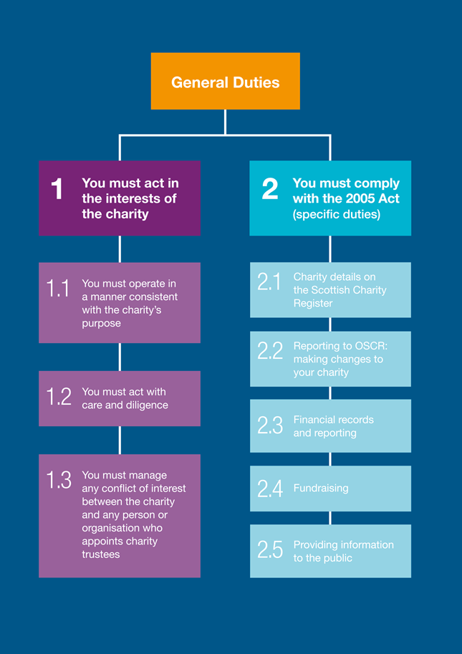

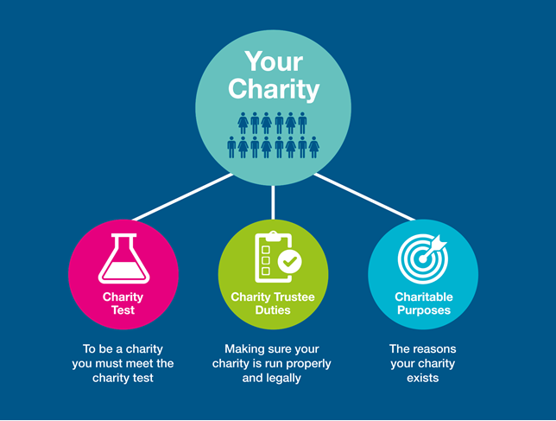

Source OSCR

## 7. Application

If you are interested in becoming a Director please complete the application form, which is downloadable from the website, and requests information about you and your skills.