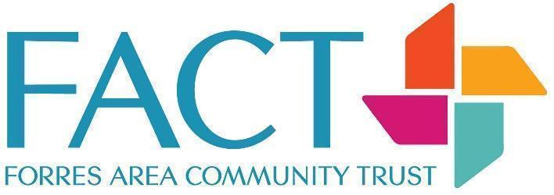**Job Title: Finance and Data Officer**

**Employer: Forres Area Community Trust**

**Pay Scale: £24,570-£27,300 pro-rata, depending on experience/qualifications**

**Hours of Work: 12-16 hours per week TBC, work pattern to be agreed**

**Responsible to: Finance Manager**

**Contract Length: 1 year – likely to be extended (subject to funding)**

**Pension: Statutory workplace pension scheme**

**Holidays: 28 days pa pro-rata (including public holidays)**

**Job Purpose**

Forres Area Community Trust (FACT) is a thriving third sector organisation that aims to make Forres a great place to live, work and play. As the organisation grows, the complexity to manage multiple streams of funding and performance data for our suite of projects and services has similarly grown. You will be the go to person for administering FACT performance data, and sharing this across the team to help us continue to reach our project / work goals. Overall you will want to develop your business improvement techniques in this post to help create efficiencies, make the best use of technology, and gather and use information well to underpin our drive to success.

**Person Specification**

**Essential**

* Experience of book-keeping, accounting or recording of financial transactions, and of using accounting software (preferably Xero, but transferable skills with other packages also welcome)
* Excellent administration and IT skills
* Accuracy and attention to detail, with a methodical approach
* A passion for collecting and working with data
* Excellent communication skills and an approachable manner
* Cooperative attitude
* Ability to work as part of a team and on own initiative

**Desirable**

* HNC/HND in Accounting
* Relevant experience within a finance role
* Credit control skills
* Payroll knowledge
* Conversant with Hallmaster Booking System, Google Docs and Excel
* Able to analyse financial and non financial information and provide it in easily digestible formats, including report writing
* Familiarity with third sector organisations
* Knowledge of the local Forres community and organisations in the area
* Experience of working with and supporting people

**Key Tasks**

* Accurate and timely processing of invoices and other financial information within the accounting software system (Xero)
* Correctly attributing all financial transactions to funding streams and projects, and reconciling to the bank accounts
* Raising and processing customer invoices
* Using credit control procedures, diligently pursuing any overdue invoices
* Assisting and monitoring automated hall bookings, ensuring all relevant paperwork is completed
* Counting, safekeeping and banking of cash transactions; accurately recording on the Xero system. Preparing and recording cash floats
* Ensuring cash, bank cards, cheque books and financial information are securely stored
* Processing bank payments for authorisation by the Finance Manager
* Providing support to assist with administration, management accounts, gift aid returns and funding claims
* Extracting performance data to support applications for funding, project reports and funding claims. Analysing, preparing and presenting the data as needed.
* Supporting the preparation of year end financial statements
* Providing essential support to the Finance Manager and Treasurer, as required
* Undertaking data collection and recording across the organisation to support the analysis of our performance and impact, including the use and development of specified recording systems. This may include client, volunteer, staff, board and stakeholder information
* Ensuring the maintenance of safe working practices and environments. Manage risks in relation to your area of work, ensuring FACT’s policies and procedures are followed
* Commitment to safeguarding and promoting the welfare of children, young people and vulnerable adults and raise any causes for concerns about individuals arising in the course of your work
* Commitment to equal opportunities and to comply with FACT’s diversity and equality policies
* Commitment to professional self development making full use of training and development opportunities identified through appraisal and six monthly review processes
* Strict compliance with financial procedures

This job description reflects the major tasks to be carried out by the post holder and identifies the level of responsibility at which they will be required to work. In the interests of effective working, the major tasks may be reviewed from time to time to reflect changing project needs and circumstances. Such reviews and any consequential changes will be carried out in consultation with the post holder.